Module:3

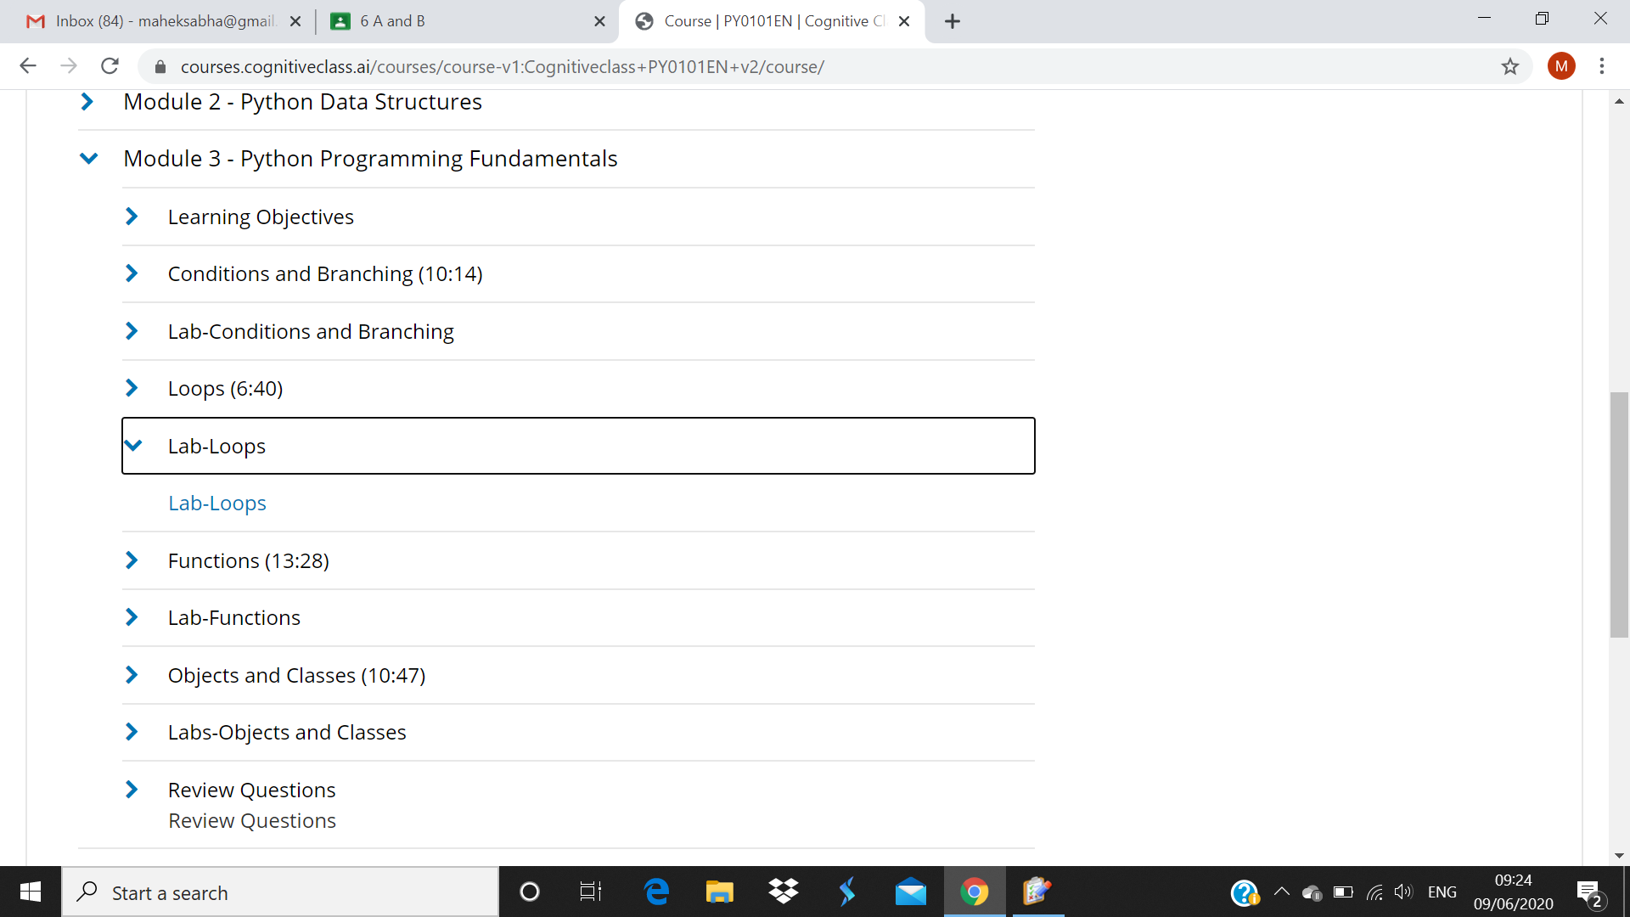

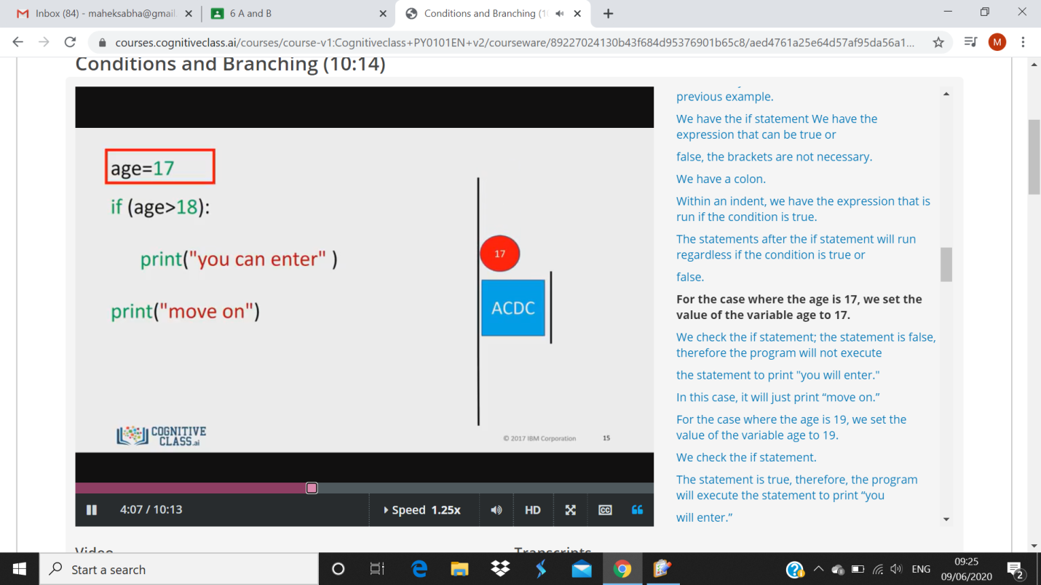

1. his is the syntax of the if statement from our previous example.
2. We have the if statement We have the expression that can be true or
3. false, the brackets are not necessary.
4. We have a colon.
5. Within an indent, we have the expression that is run if the condition is true.
6. The statements after the if statement will run regardless if the condition is true or
7. false.
8. For the case where the age is 17, we set the value of the variable age to 17.